Rodrigo Brasil 09/2023

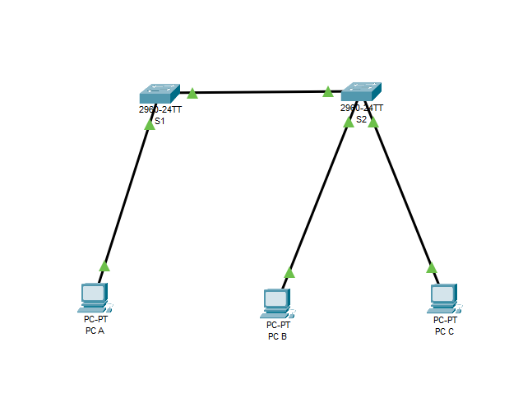





IP do PC A IP do PC B



IP do PC C





Vlan Student do switch S1 Vlan Student e Faculty do switch S2

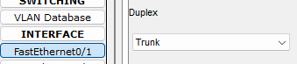

Switch S1 com Trunk para o Switch S2 no FastEthernet0/1



Switch S1 com FastEthernet0/2 configurado para aceder apenas a vlan 10 (Student)

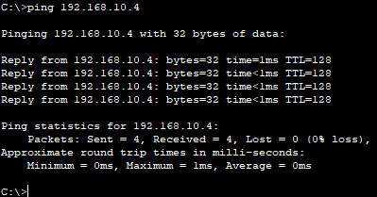

Ping do PC A para o PC B

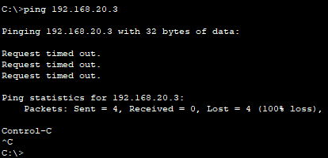

Ping do PC A para o PC C